**Name: Akshita Pathak**

**Roll No: 102203796**

**Subgroup: 2CO18**

**Lab Assignment 5**

1. **Write a program to Eulerian path and circuit, given an undirected/directed graph.**

#include<iostream> #include <list>

using namespace std; class Graph

{

int V; list<int> *adj;

public:Graph(int V) {this->V = V; adj = new list<int>[V]; }

~Graph() { delete [] adj; } void addEdge(int v, int w); int isEulerian();

bool isConnected();

void DFSUtil(int v, bool visited[]);

};

void Graph::addEdge(int v, int w)

{

adj[v].push_back(w); adj[w].push_back(v);

}

void Graph::DFSUtil(int v, bool visited[])

{

visited[v] = true; list<int>::iterator i;

for (i = adj[v].begin(); i != adj[v].end(); ++i) if (!visited[*i])

DFSUtil(*i, visited);

}

bool Graph::isConnected()

{

bool visited[V]; int i;

for (i = 0; i < V; i++)

visited[i] = false; for (i = 0; i < V; i++)

if (adj[i].size() != 0)

break;

if (i == V)

return true;

DFSUtil(i, visited);

for (i = 0; i < V; i++)

if (visited[i] == false && adj[i].size() > 0)

return false;

return true;

}

/* The function returns one of the following values

1. If graph is not Eulerian
2. If graph has an Euler path (Semi-Eulerian)
3. If graph has an Euler Circuit (Eulerian) */ int Graph::isEulerian()

{

if (isConnected() == false) return 0;

// Count vertices with odd degree int odd = 0;

for (int i = 0; i < V; i++)

if (adj[i].size() & 1)

odd++;

// If count is more than 2, then graph is not Eulerian if (odd > 2)

return 0;

return (odd)? 1 : 2;

}

void test(Graph &g)

{

int res = g.isEulerian(); if (res == 0)

cout << "graph is not Eulerian\n"; else if (res == 1)

cout << "graph has a Euler path\n";

else

}

cout << "graph has a Euler cycle\n";

int main()

{

Graph g1(5); g1.addEdge(1, 0);

g1.addEdge(0, 2);

g1.addEdge(2, 1);

g1.addEdge(0, 3);

g1.addEdge(3, 4); test(g1);

Graph g2(5); g2.addEdge(1, 0);

g2.addEdge(0, 2);

g2.addEdge(2, 1);

g2.addEdge(0, 3);

g2.addEdge(3, 4);

g2.addEdge(4, 0); test(g2);

Graph g3(5); g3.addEdge(1, 0);

g3.addEdge(0, 2);

g3.addEdge(2, 1);

g3.addEdge(0, 3);

g3.addEdge(3, 4);

g3.addEdge(1, 3); test(g3);

Graph g4(3); g4.addEdge(0, 1);

g4.addEdge(1, 2);

g4.addEdge(2, 0); test(g4);

Graph g5(3); test(g5);

return 0;

}

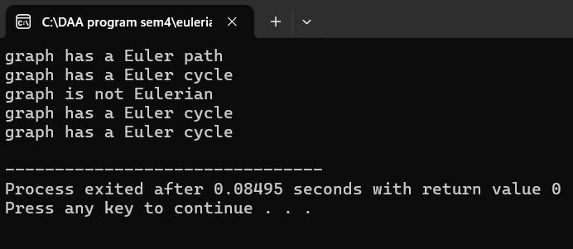

1. **Given an adjacency matrix representation of an undirected graph consisting of N vertices, write a program to find whether the graph contains a Hamiltonian Path or not. If found to be true, then print “Yes”.**

**Otherwise, print “No”.**

#include <iostream> #include <cstring> using namespace std;

const int MAXN = 10;

bool isSafe(int node, int graph[MAXN][MAXN], int path[], int pos) { if (graph[path[pos - 1]][node] == 0) {

return false;

}

for (int i = 0; i < pos; i++) { if (path[i] == node) {

return false;

}

}

return true;

}

bool hamiltonianPathHelper(int graph[MAXN][MAXN], int path[], int pos, int n) { if (pos == n) {

return true;

}

for (int node = 1; node < n; node++) {

if (isSafe(node, graph, path, pos)) { path[pos] = node;

if (hamiltonianPathHelper(graph, path, pos + 1, n)) { return true;

}

path[pos] = -1;

}

}

return false;

}

bool hasHamiltonianPath(int graph[MAXN][MAXN], int n) { int path[MAXN];

memset(path, -1, sizeof(path));

for (int start = 0; start < n; start++) { path[0] = start;

if (hamiltonianPathHelper(graph, path, 1, n)) { return true;

}

}

return false;

}

int main() {

int graph[MAXN][MAXN] = {

{0, 1, 1, 0, 0},

{1, 0, 1, 1, 0},

{1, 1, 0, 1, 1},

{0, 1, 1, 0, 1},

{0, 0, 1, 1, 0}

};

int n = 5;

if (hasHamiltonianPath(graph, n)) { cout << "Yes" <<endl;

} else {

cout << "No" <<endl;

}

return 0;

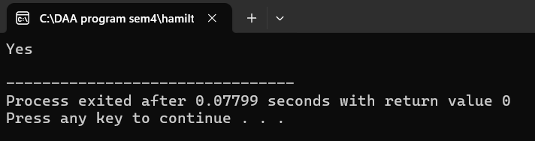}

1. **Write a program for finding the Hamiltonian Cycle or Hamiltonian Circuit in a graph using backtracking**

#include <bits/stdc++.h> using namespace std; #define V 5

void printSolution(int path[]);

bool isSafe(int v, bool graph[V][V],

int path[], int pos)

{

if (graph [path[pos - 1]][ v ] == 0) return false;

for (int i = 0; i < pos; i++)

if (path[i] == v)

return false;

return true;

}

bool hamCycleUtil(bool graph[V][V],

int path[], int pos)

{

if (pos == V)

{

if (graph[path[pos - 1]][path[0]] == 1) return true;

else

return false;

}

for (int v = 1; v < V; v++)

{

if (isSafe(v, graph, path, pos))

{

path[pos] = v;

if (hamCycleUtil (graph, path, pos + 1) == true) return true;

path[pos] = -1;

}

}

return false;

}

bool hamCycle(bool graph[V][V])

{

int *path = new int[V]; for (int i = 0; i < V; i++)

path[i] = -1;

path[0] = 0;

if (hamCycleUtil(graph, path, 1) == false )

{

cout << "\nSolution does not exist"; return false;

}

printSolution(path); return true;

}

void printSolution(int path[])

{

cout << "Solution Exists:"

" Following is one Hamiltonian Cycle \n"; for (int i = 0; i < V; i++)

cout << path[i] << " ";

cout << path[0] << " "; cout << endl;

}

int main()

{

bool graph1[V][V] = {{0, 1, 0, 1, 0},

{1, 0, 1, 1, 1},

{0, 1, 0, 0, 1},

{1, 1, 0, 0, 1},

{0, 1, 1, 1, 0}};

hamCycle(graph1);

bool graph2[V][V] = {{0, 1, 0, 1, 0},

{1, 0, 1, 1, 1},

{0, 1, 0, 0, 1},

{1, 1, 0, 0, 0},

{0, 1, 1, 0, 0}};

hamCycle(graph2);

return 0;

}

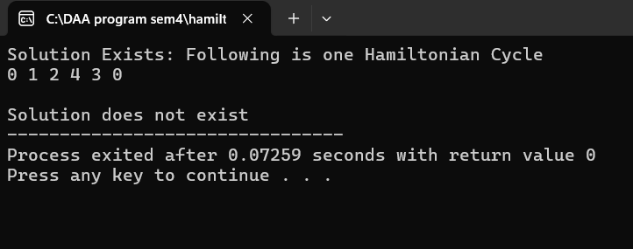

1. **Topological sort using Kahn algo and** DFS #include <bits/stdc++.h>

using namespace std;

vector<int> topologicalSort(vector<vector<int> >& adj,

int V)

{

vector<int> indegree(V); for (int i = 0; i < V; i++) {

for (auto it : adj[i]) {

indegree[it]++;

}

}

queue<int> q;

for (int i = 0; i < V; i++) {

if (indegree[i] == 0) {

q.push(i);

}

}

vector<int> result; while (!q.empty()) {

int node = q.front(); q.pop();

result.push_back(node); for (auto it : adj[node]) {

indegree[it]--;

if (indegree[it] == 0)

q.push(it);

}

}

if (result.size() != V) {

cout << "Graph contains cycle!" << endl; return {};

}

return result;

}

int main()

{

int n = 4;

vector<vector<int> > edges

= { { 0, 1 }, { 1, 2 }, { 3, 1 }, { 3, 2 } };

vector<vector<int> > adj(n); for (auto i : edges) {

adj[i[0]].push_back(i[1]);

}

cout << "Topological sorting of the graph: "; vector<int> result = topologicalSort(adj, n); for (auto i : result) {

cout << i << " ";

}

return 0;

}

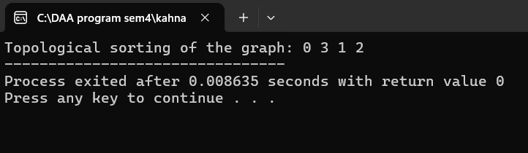

1. **Write a program to implement Ford-Fulkerson algorithm for Maximum Flow** Problem #include <iostream>

#include <queue> #include <cstring> using namespace std; const int MAXN = 10;

bool bfs(int graph[MAXN][MAXN], int n, int source, int sink, int parent[]) { bool visited[MAXN];

memset(visited, false, sizeof(visited)); queue<int> q;

q.push(source);

visited[source] = true; parent[source] = -1; while (!q.empty()) {

int current = q.front();

q.pop();

for (int i = 0; i < n; i++) {

if (!visited[i] && graph[current][i] > 0) { q.push(i);

visited[i] = true;

parent[i] = current; if (i == sink) {

return true;

}

}

}

}

return false;

}

int fordFulkerson(int graph[MAXN][MAXN], int n, int source, int sink) { int residual[MAXN][MAXN];

memcpy(residual, graph, sizeof(residual)); int parent[MAXN];

int max_flow = 0;

while (bfs(residual, n, source, sink, parent)) { int path_flow = INT_MAX;

for (int v = sink; v != source; v = parent[v]) { int u = parent[v];

path_flow = min(path_flow, residual[u][v]);

}

for (int v = sink; v != source; v = parent[v]) { int u = parent[v];

residual[u][v] -= path_flow; residual[v][u] += path_flow;

}

max_flow += path_flow;

}

return max_flow;

}

int main() {

int graph[MAXN][MAXN] = {

{0, 16, 13, 0, 0, 0},

{0, 0, 10, 12, 0, 0},

{0, 4, 0, 0, 14, 0},

{0, 0, 9, 0, 0, 20},

{0, 0, 0, 7, 0, 4},

{0, 0, 0, 0, 0, 0}

};

int n = 6;

int source = 0; int sink = 5;

int max_flow = fordFulkerson(graph, n, source, sink); cout << "Maximum flow: " << max_flow << endl; return 0;

}

